***First problem statement***

*NASA wishes to 3D print radiation shelters on Mars. Some of the regolith has been identified as suitable for 3D printing. NASA requires a prototype rover system to collect the resource and bring it to the collection area. The range of the system is over a 3m^2 area with an upper bound of 3m in the x and y directions. The rate of resource collection should be a great as possible. The rate of collection will be measured in kg/ 240 sec period. The system should be suitable for transport and operation in the Martian environment. It should consume as little power as possible.*

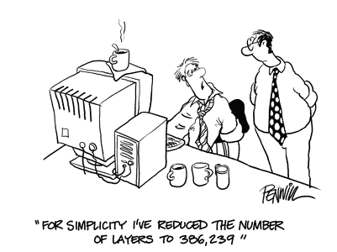

**Significance of problem statements**

Problem statements are significant because they outline the problem that we as engineers are trying to find solutions to. If the problem statement is incorrect or unclear the solution, we build may partially or completely fail to address the actual problem. Therefore, getting the problem statement correct is an extremely important part of the design process.

**Considerations**

**Who?**

A group of first year engineering students are required to build a rover in a period of about 10 weeks. The design objective is ‘…your team is to design and build a prototype rover that is able to transport on a **Mars-like surface** and collect resources.’

The client is ‘NASA’ but in relation to the actual problem the client is the course assessor and at least to some degree, our team as we will be the ones operating it.

**What?**

**Objectives:**

The objective is to build a rover that can transit on a Mars-like surface (beach terrain with small rocks, sandhills and recesses) and collect resources (small pebbles or gravel).

**Constraints:**

The constraints are:

Limited skills - it must be built by undergraduate students with little or no experience in building robots.

Limited time: - a working prototype must be produced in ten weeks.

It must also operate in a 3*3m environment so must be small enough to manoeuvre in this space and large enough to carry approx. 1 kg to 5kg of simulated regolith. More is better.

**The assessment marking emphasises the following points:**

Our mentor pointed out that from past years the probability of a team producing a rover in the time available is ~50% and the likelihood of producing a working rover is ~30%.

1. *Produce a rover. Binary Y/N*
2. *The rover is able to move about on a ‘Mars like surface’ and collect resources in the ten-week time period. Binary Y/N*
3. *A high rate of collection. Non-binary but measurable in kg per second.*
4. *Energy consumption – non-binary and measurable as mAh consumed.*
5. *Innovation - non-binary and subjective but related to execution of 1 – 4.*

Key Issues: - Limited time and skills

Action: - Simple - easy to design, build and operate.

Other considerations:

Powerful – able to move about and collect resource quickly. Must be considered with efficiency requirement.

Energy Efficient – no un-necessary systems. Must be considered in balance with power required.

***Tried to outline the problem specifically with defined metrics.***

***Revised problem statement***

*As part of their assessment for a first-year engineering programme students are required to produce a working prototype of a rover. The rover must be built by the students in ten weeks. It must be able to move about on a Mars like surface (simulated by beach terrain with small rocks, sandhills and recesses) and collect resources (simulated by small pebbles/gravel). The ‘Mars-like’ area is approximately 9 m^2 and the rover will be required to operate continuously for 4 minutes.*

*The project will be marked on performance against five objectives. Four are objectively measurable. (in order of precedence)*

1. *Produce a rover. Binary Y/N*
2. *The rover is able to move about on a ‘Mars like surface’ and collect resources in the ten-week time period. Binary Y/N*
3. *A high rate of collection. Non-binary but measurable in kg per second.*
4. *Energy consumption – non-binary and measurable as mAh consumed.*
5. *Innovation - non-binary and subjective but related to execution of 1 – 4.*